Cherishing Sidmouth Cemetery
Creating and implementing a management schedule for Sidmouth Cemetery is a difficult task. Managing such a large area that is interspersed with the many stone monuments is hard enough, but a cemetery brings emotional perspectives that require balancing very different views and objectives of committed stakeholders. There are those who are directly involved because it is the resting place for their relatives and they do not agree on how they would like their relatives to be honoured. Added to that, the cemetery is a public space and all residents have varying levels of involvement.
At two ends of the spectrum, family members range from people who want a neatly manicured garden of remembrance with tended flower beds, others see it as space that can be set aside to allow nature to flourish perhaps going as far as developing a woodland burial site. In between there is a range of views with different levels of commitment.
I suspect that this is no different to the range of opinions among other local people who do have a view. The regular debates in local print and social media tend towards the infra red and ultra violet ends of the spectrum but the majority of local residents are probably somewhere in the middle which happens to be green in my analogy.
The cemetery is large and different areas enjoy very different levels of public interest, that allows for a balanced approach. A compromise regime was drawn up in 2020 with input from ex-councillors Denise Bickley and Jenney Ware. The upper section, the location for most recent burials, was to cut regularly, and the original Victorian sections where the majority of graves are not visited was to be cut under a traditional hay meadow regime enhanced with regular cutting of some access pathways.
The upper area is being managed by regular cutting and this is quite successful with the sward being kept under control but it is studded with ground hugging wild flowers such as common daisy, creeping buttercup, dandelions and various speedwells and these are a welcome food source for flying insects.
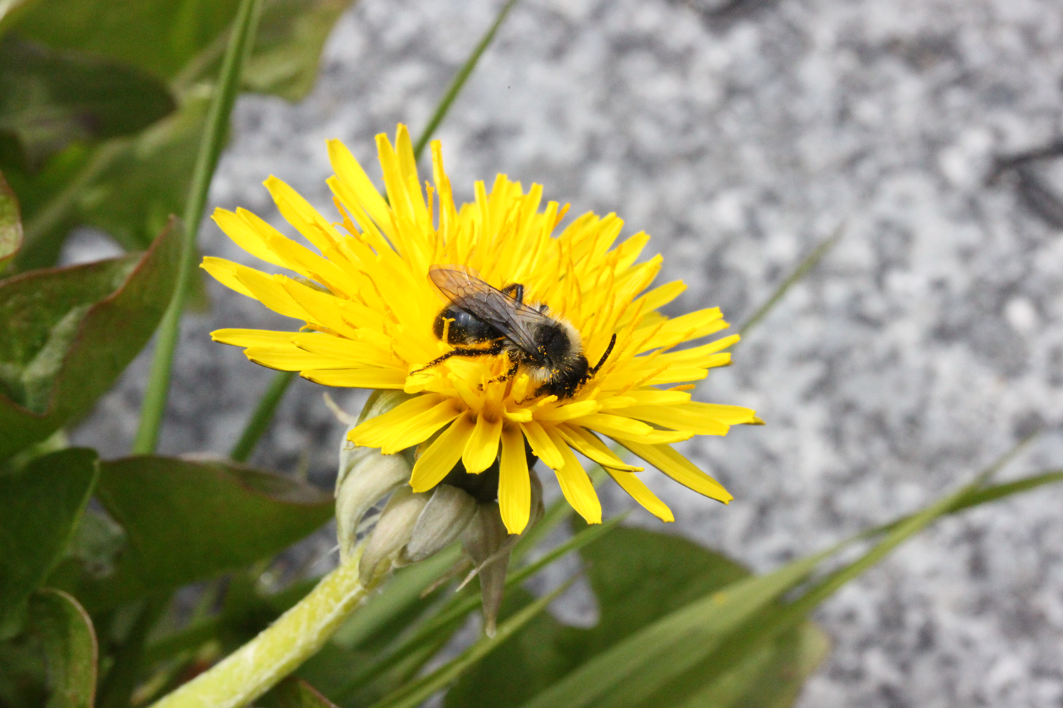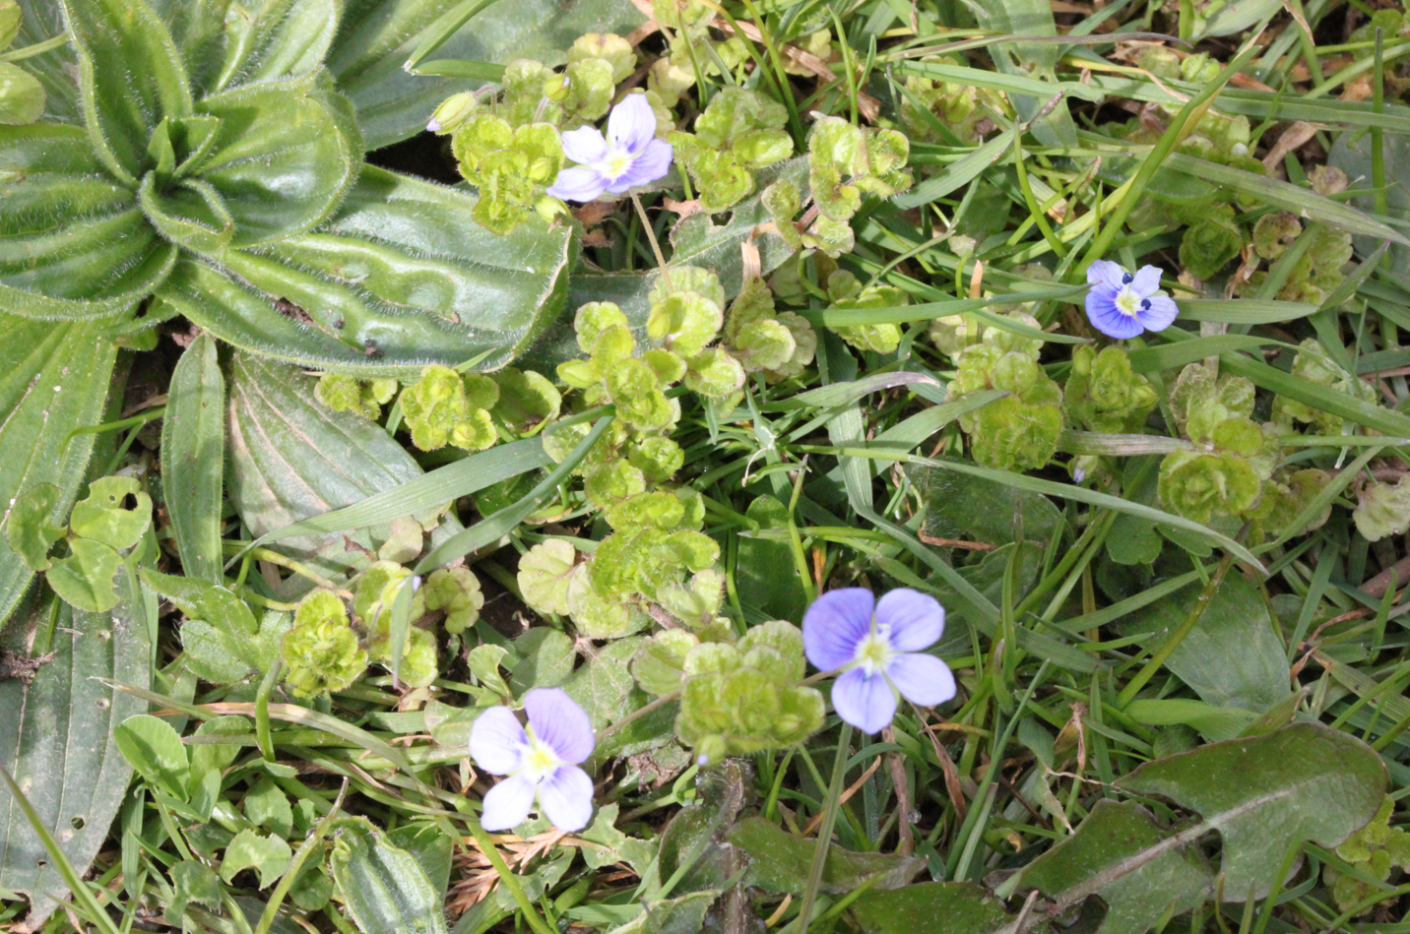
Mining Bee on a cemetery Dandelion Slender Speedwell in the cemetery
On the other hand, the original Victorian areas could be said to be of use to neither man nor beast, the current state is not satisfying either end of the opinion spectrum and it has limited value to nature. The areas have not been cut according to the agreed regime this year. The access pathways were not cut regularly during the summer and the August cut did not happen, the area is still uncut at the end of October. I visited the cemetery today but there is no sign of pathways being kept clear in the long grass and in the current weather you risk getting a soaking if you want to access a grave and haven’t brought wellingtons.
The southern section around the chapel is even worse because it does not appear to have been cut in the last two years. The result is that brambles are well established and, apart from the extra difficulty this will cause when it is cut eventually, even the most ardent naturalist is likely to find this inappropriate in such a sensitive site.
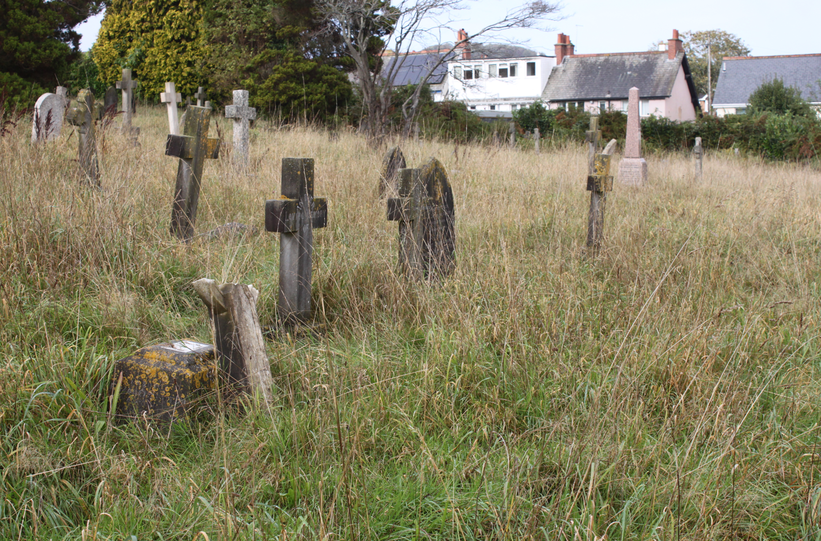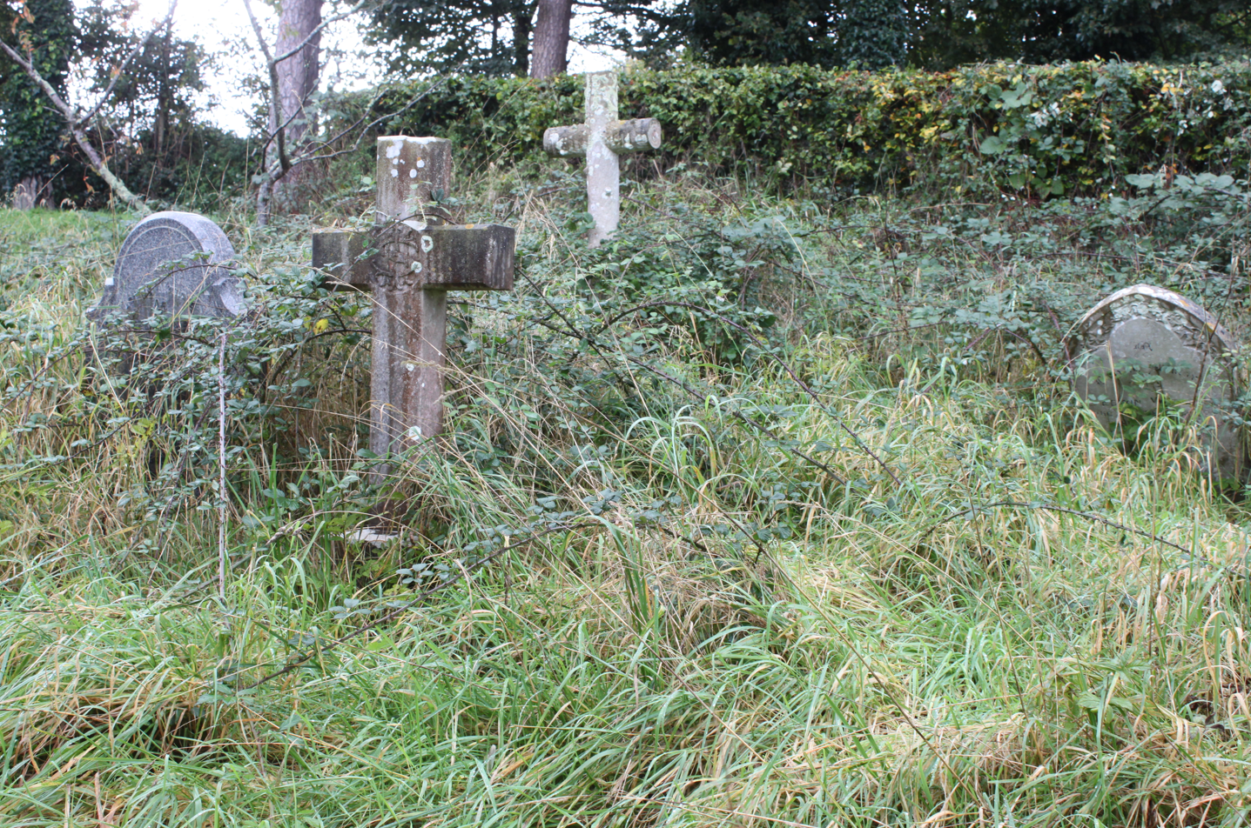
Still uncut on 29th October Brambles taking over
I am not sure why the plan has not been followed this year but I suspect lack of resources, personnel and equipment, will be a factor. Trying to do a hay cut requires the appropriate equipment and working around the stone monuments is even more difficult. I think this is only going to work if the maintenance team are supported by volunteers. I believe there were attempts to start a group in 2020 but these came to nothing. I welcome the VGS attempt to revive the idea and wish them luck. I am not a fan of the choice of title including the word cherishing, but I am not the audience that you are trying to reach.
As I have said during other discussions with EDDC, if the district’s green spaces are to be managed for nature then there are a number of steps that need to be in place.
- It needs to be decided what nature you want to encourage. For example, are you supporting grassland butterflies or the main flying pollinators, these two groups have very different needs.
- It needs to be decided if an individual space is appropriate for the overall scheme.
- It needs to be decided what practical measures will work in the particular space to support which particular species groups. In the case of the cemetery the needs of its human users are a more significant consideration than in some other sites.
- The site limitations need to be recognised.
- The scale of necessary resources needs to be established.
- Public engagement needs to be at a far more effective level than is currently the case, both in selling the idea and in maximising the usefulness of a site for public education.
I have not commented on what I would choose to be done beyond supporting the simple outline of the 2020 scheme which was backed with some comprehensive details provided by others including the excellent ideas from Kate Tobin. If EDDC councillors and managers are serious about tackling this project properly then I will be happy to make specific suggestions but, having wasted time and effort preparing a detailed proposal for the parish church that came to nothing because of stated difficulties that inferred a lack of will at some levels of management rather than insurmountable barriers, I prefer to spend my time on more productive pursuits.
Ed Dolphin

